Compare & Graph Ratios
You must earn 6 points!
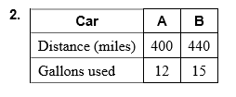
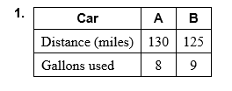
Determine which car gets the best gas mileage.
1
point

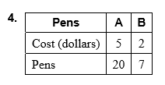
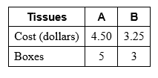
Find the best buy.
3.

5. Protein Bar A has 15 grams of protein in a 40 gram bar. Protein Bar B has 20 grams of protein in a 60 gram bar. Which bar has more protein per gram?

6. You are choosing a song for your dance recital. Song A has 11 beats in 10 seconds. Song B has 7 beats in 6 seconds. Which song has the greater rate?

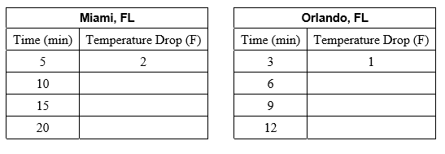
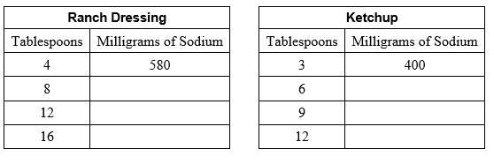
Complete the ratio tables and graph the ordered pairs from the table. What can you conclude?
7. 8.
2
points

9. The deli offers a fruit salad with 5 blueberries for every 3 pieces of cantaloupe. The deli changes the mixture to have 6 blueberries for every 4 pieces of cantaloupe, but the number of pieces of fruit in the salad does not change.
a. Create a ratio table for each salad. How many blueberries are in the smallest possible salad?

b. Blueberries cost less than cantaloupe. Should the company charge more or less for the new salad? Explain your reasoning.

Re
Reflecting Back
You must complete ALL 6 problems!

- Divide. Write your answer in simplest form.
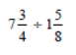

- Divide.

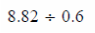

- Use the Distributive Property to simplify the expression.
12(y + 5)

- Write the inequality
You can eat no more than 10 cookies.

- Find the Greatest Common Factor (GCF) & the Least Common Multiple (LCM).
15 and 35

- Evaluate the expression. (15 ÷ 5) + 3² + (14 – 5) • 3

